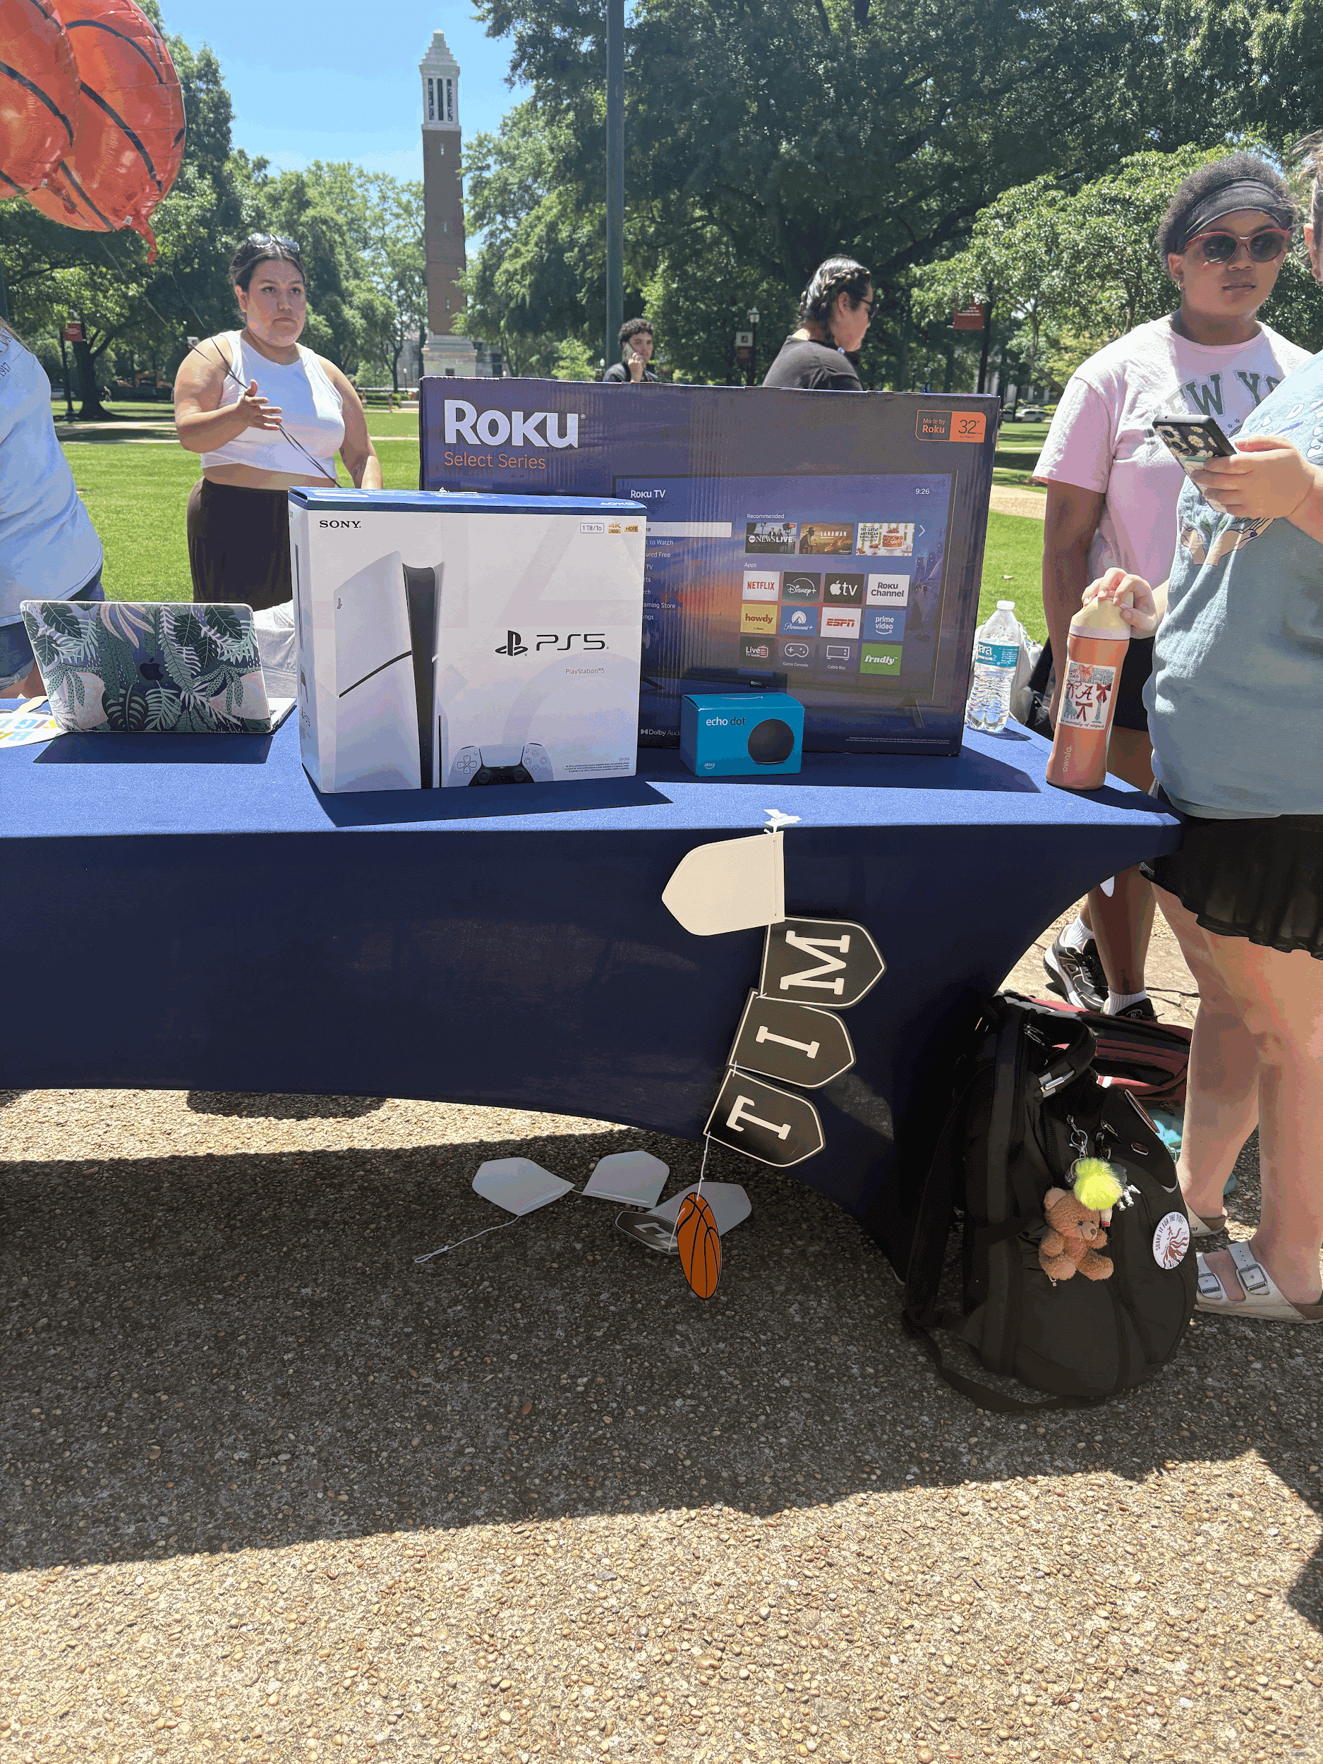
Sigma Delta Tau fundraiser on the Quad supports Jewish Women International
The prizes were displayed for students to see what they were competing for.

By Joanna House

TUSCALOOSA, Ala. — Sigma Delta Tau raised money for Jewish Women International on April 15 through a basketball shooting competition on the University of Alabama Quad, where students paid $5 to compete to make as many baskets as possible in 60 seconds for the chance to win prizes including a PlayStation 5 and a television.

The event was one of three philanthropy fundraisers the sorority holds each semester, according to organizers. Sigma Delta Tau members said they designed the competition to be simple, competitive, and welcoming to students passing through the Quad.
“We like our events to be inclusive for everyone,” said Amaya Esquivel, Sigma Delta Tau’s director of philanthropy.
That accessibility appeared to work. Students stopped between classes to take their turn, cheer on friends, and watch the leaderboard change throughout the afternoon.
Bennett Nickel, a University of Alabama student, said the prizes added extra motivation.
“I think the prizes are awesome,” Nickel said during the event. “The PS5 is what I’m going for, and I think I can make that happen.”
At the time of the interview, Nickel held a nine-point lead. By the end of the competition, he finished in second place and won a 32-inch Roku TV.
While the basketball challenge created excitement, members said the larger purpose was supporting Jewish Women International, the chapter’s primary philanthropic beneficiary.
Jewish Women International works to help women survive and recover from domestic violence and other forms of gender-based violence. The organization also provides education, advocacy, and support services for women and families.
Sigma Delta Tau chapters nationwide support several causes, including Prevent Child Abuse America, Jewish Women International, and the Sigma Delta Tau Foundation.
The sorority’s connection to Jewish Women International is rooted in its history. Sigma Delta Tau was founded in 1917 by seven Jewish women, and many chapters continue to prioritize support for JWI through campus fundraising efforts.
As students lined up for one more shot at the top score, the event showed how a quick game on the Quad could carry a larger impact.

